Software Development and Test Technician Exam
Developer Documentation 2025

Made by: Szonda Mercédesz, Kósa Nátán, Bakó Bence

Contents:

Introduction
Description
Database installation process
Installation
Other

introduction
We developed a web store selling drinks because we thought it was a very realistic and practical project task that fits well with the goals and challenges expected in the job. Although the website is not yet completely final and there are some places where the design and user experience need to be refined, the current functions are already working properly. Users can easily browse products, create a cart, place orders, and all basic functions work well. Our goal is for the system to gradually develop and become even more convenient and transparent in the future.
After logging in, you must verify that you are over 18 years old!. 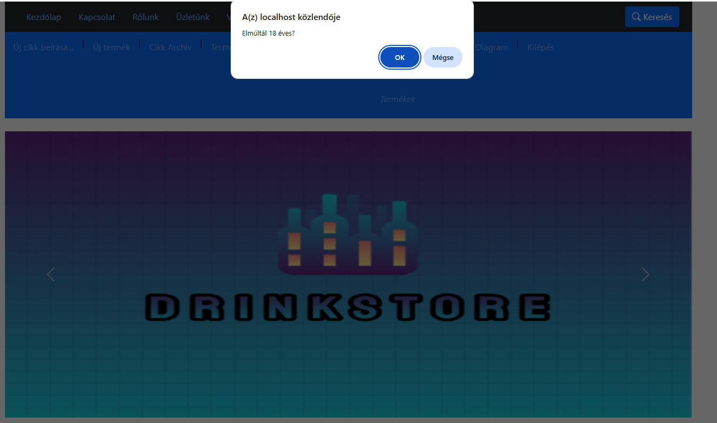

Our homepage: 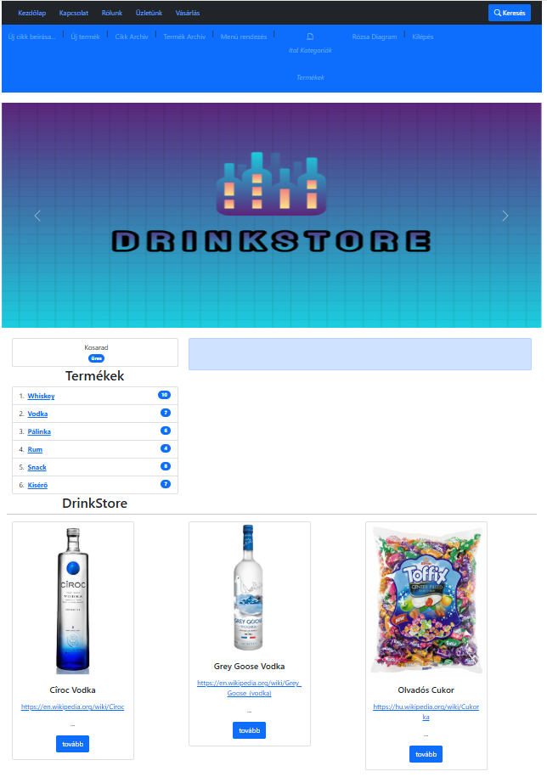

Our website has the features of a DrinkStore. You can get information and add drinks of any quality and quantity to your basket without registration.
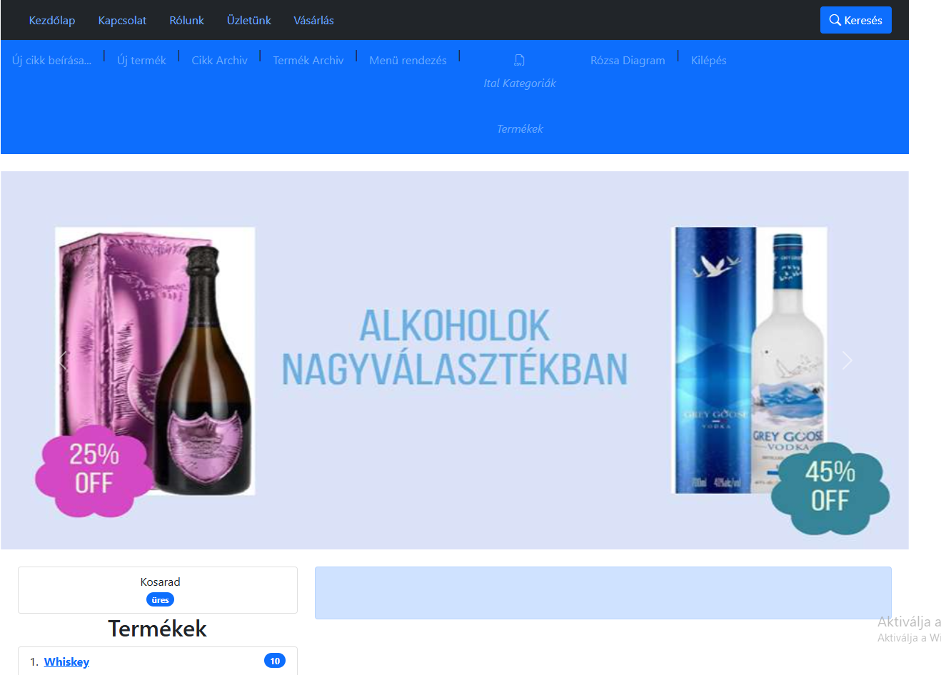
The main menu of the page is located in the header of the page, where you can read various articles under the menu items. Home page, Contact or About us, etc. These pages may contain various articles that are information, news or information related to the drink discount.
In the header menu, the current page cannot be clicked, its color has become darker.

On the right-hand side, there is a search label, which, if clicked, will open a window in which you can search for anything. This is whatever you are looking for in the content and descriptions of the pages, of course also among the products. You can click on the displayed results and view the entire content.

In the window, the search engine looks for results by typing:
This is an online search function that helps you search the database. Clicking on the listed result will take you to the new page.If there are no results, our program will also display them. We can close the window by closing it or by simply clicking somewhere next to the window. since Wikipedia is linked in the product descriptions, all products containing the word Wiki are listed. Product description, product name and content of page articles are included in the search. Of course, the query can be modified by us upon request.
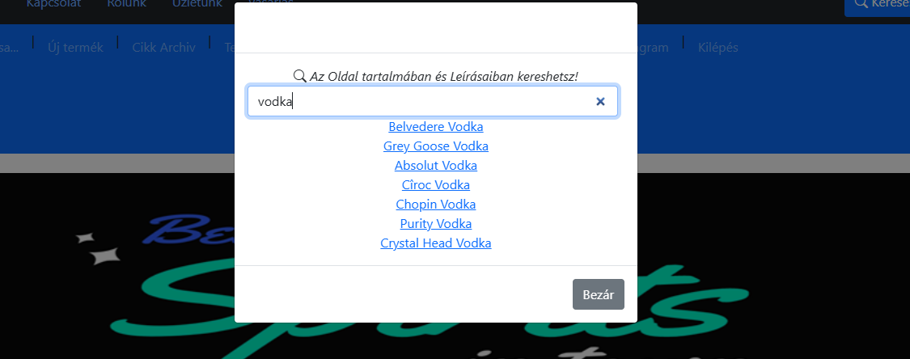
But we think it is sufficient to search for the relevant words in the content and names of the articles and products in the database. As you can see, a nice set of results can be generated for the hits. 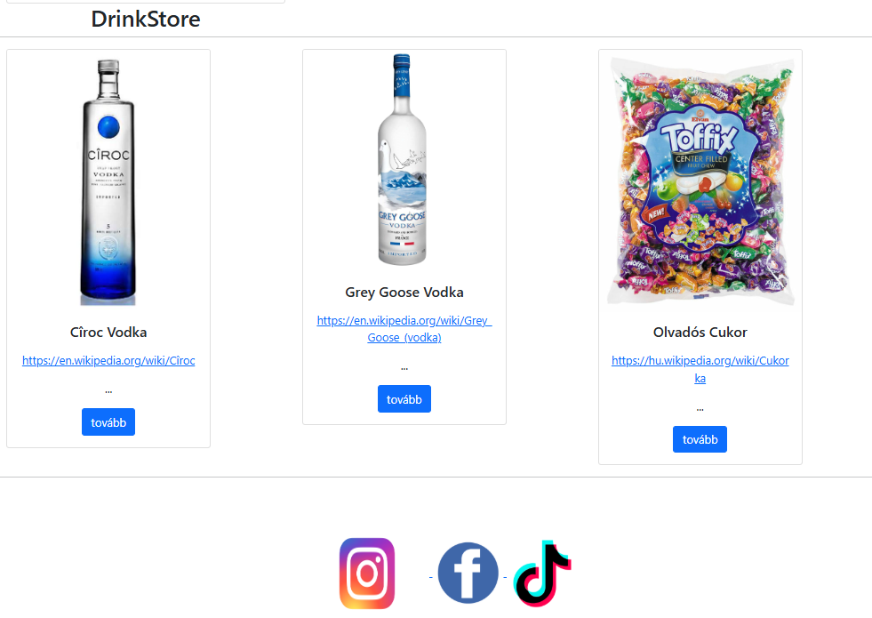

Cart function and product menu:
A the display of the status of our basket is continuous! This will appear on the left above the names of the Products group. In order to be able to add a product to the cart, it is not necessary to register or enter the site with username or password.
The product menu currently includes groups of alcoholic beverages. Next to the names, there is a list of how many products are included and what is in stock at the Discount Store. By clicking on the names, the group opens and the names of the drinks in the group are listed.
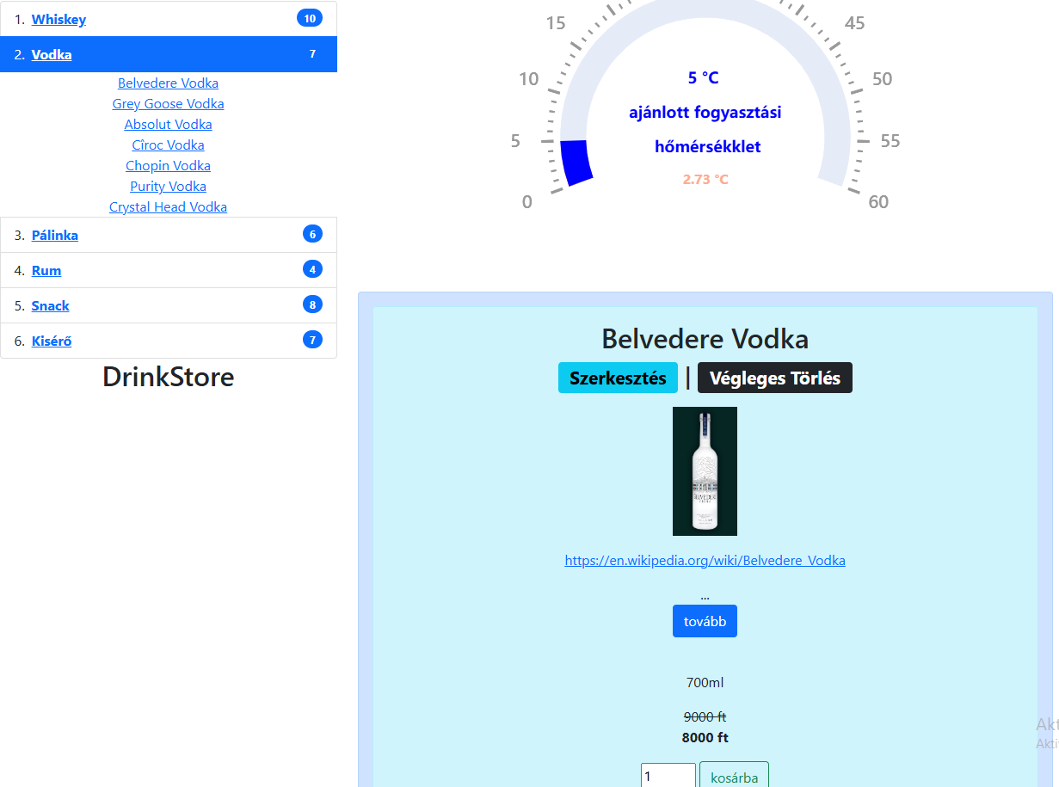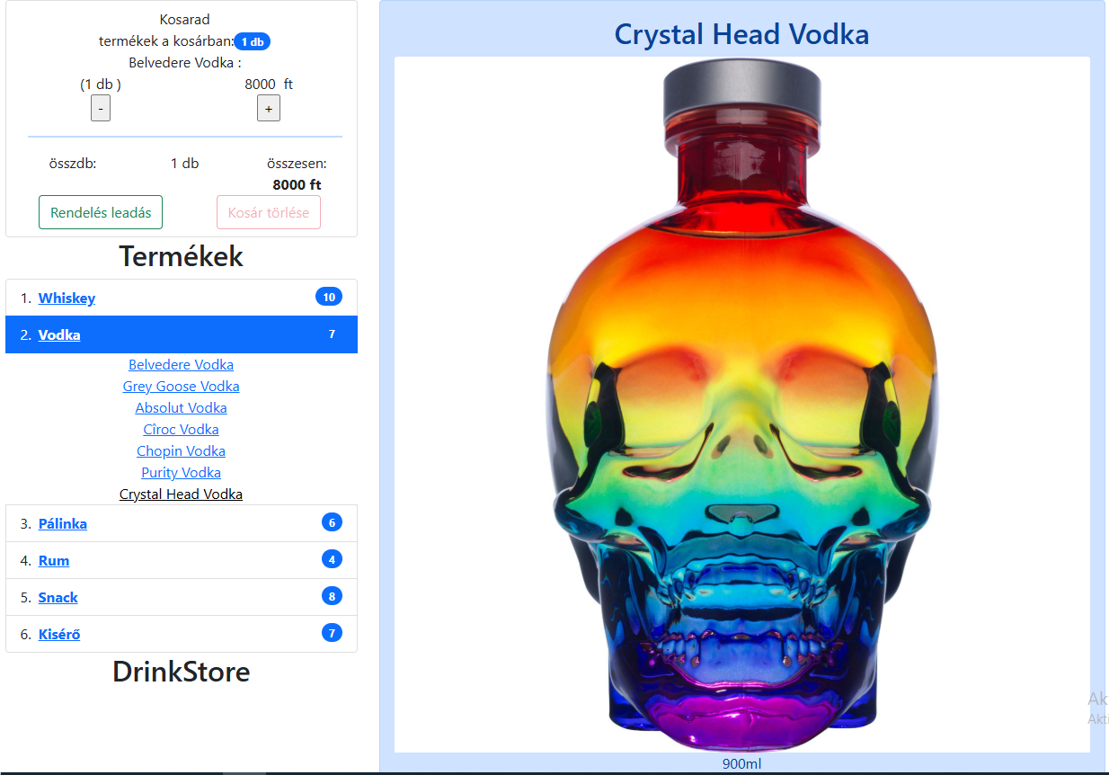
In the list that opens, the name of the product whose data sheet we are currently viewing is colored in black. Whether in the group or on the product data sheet, there is always an ADD TO BASKET button for each product with the option to enter a number next to it. With this option, you can add as much as you like to our basket at the push of a button.

Our basket indicates that there is 1 product in the basket, what is its name and how much does it cost. Here you can add or take away pieces in the basket one by one. The PLACE ORDER and DELETE CART functions have also been added. These buttons change to a vivid color when you move the mouse over them. This can be seen in the two pictures below.
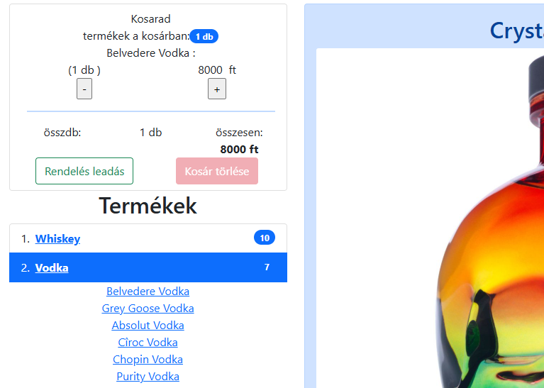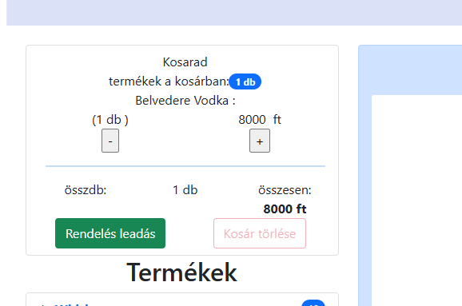

The order can be edited locally, you can add or remove it with the + button. We can also delete the contents of our basket or place the order.
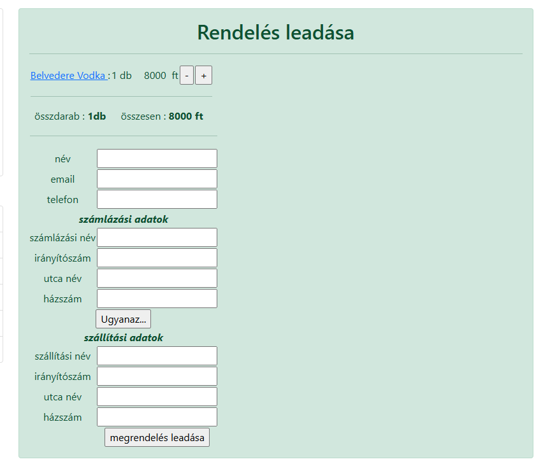

Placing an order:
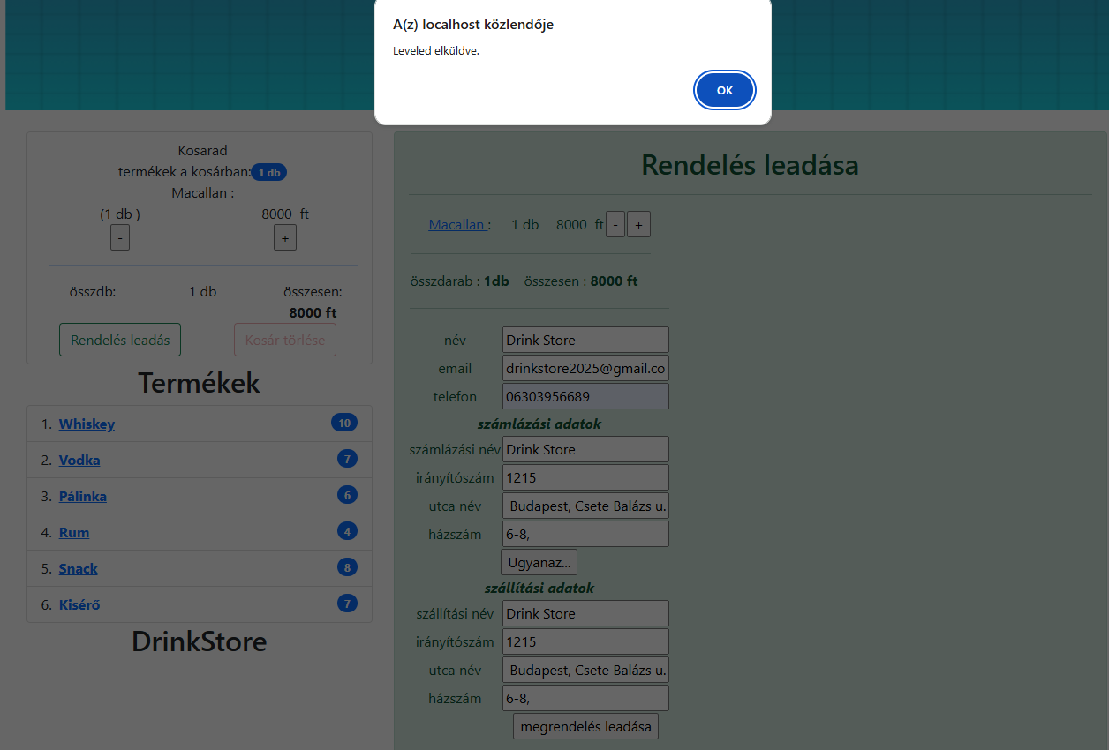
By clicking on place an order, you will be taken to our order form, where the data must be entered. Filling in all data is mandatory!
By clicking the same button, the delivery address will be filled in automatically!

.

Pop-ups indicate that the data has been recorded and a confirmation email has been sent.

We are currently arriving at a Not Found page, as the development has not yet reached a status where the order can be viewed and tracked by users. This is part of further development.
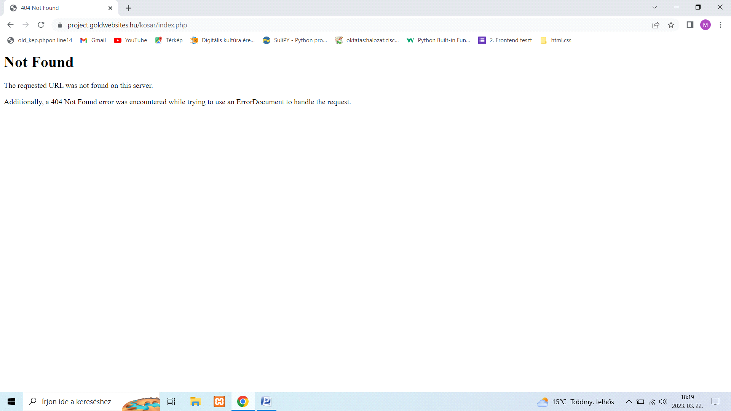
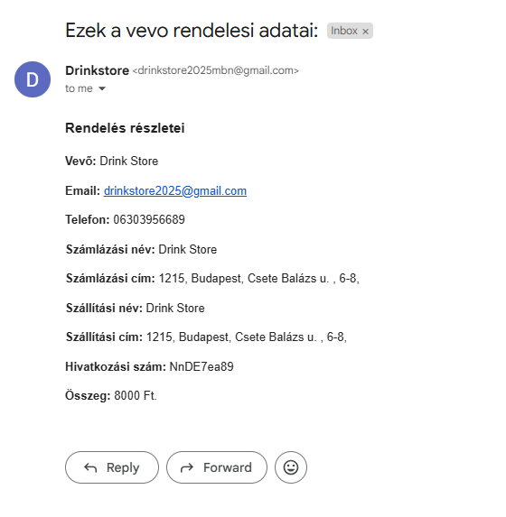
Despite this, the email was sent and the data of the ordered products were stored in the Drink Discount database.

The confirmation email looks like:
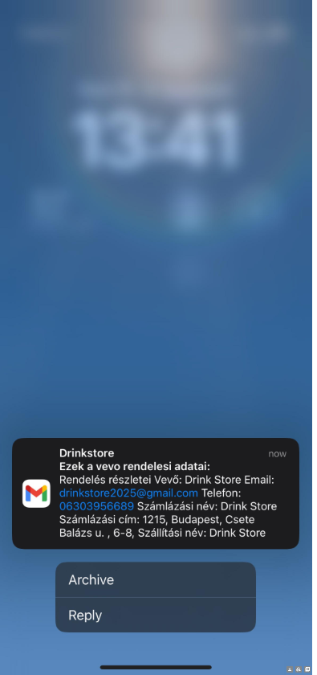
And a screenshot of the received email address on Iphone phone.
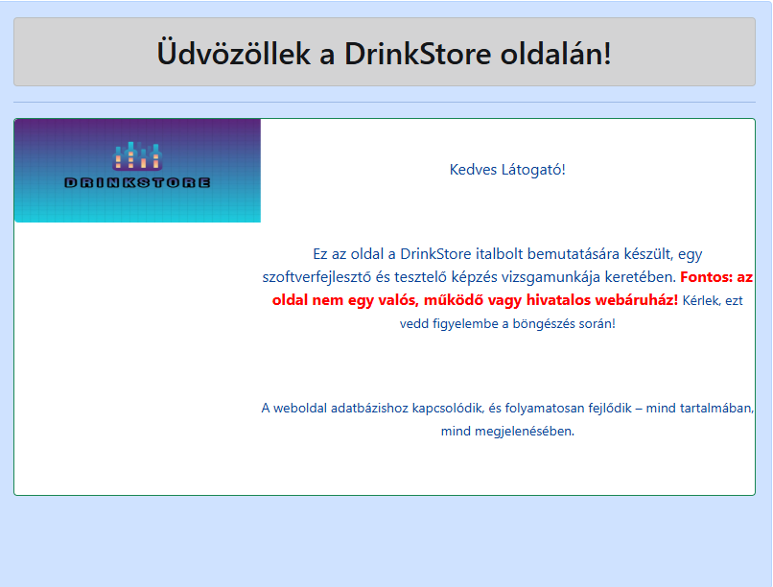
As a further development, we will have a contact form. Which immediately sends an email to the customer and the site operator (also stored in the database) and can be answered via the Admin interface there will be optional development.
Another function of the site is the ADMIN interface, which is tightly integrated into the site. This interface is the domain of the site owner or manager. It can be accessed with a password and username on a separate link, which is not shown on the site. It is, so to speak, hidden from ordinary users.
Access to the admin interface: localhost/drinkstore.hu/modul/login.php
for testing and for Admin authorization the username: drinkstore
password: 2025
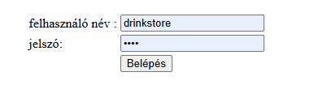
By entering the admin interface, our menu bar expands:
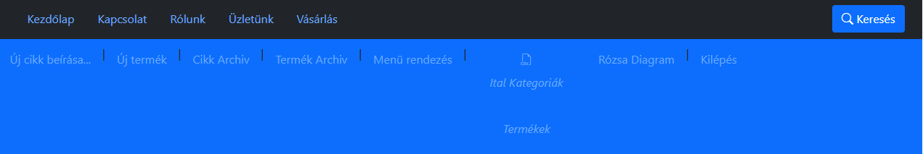
With admin rights it is possible to:
- to write a new article, to create a new menu item for it, if we want to put the new article under an existing menu item. uploading a new product to an existing product group or we can create a new one for it.
- Deleted articles can be found in the article archive, from where they can be restored or permanently deleted.
- Deleted products can be restored or permanently deleted in the product archive.
- Menus can be renamed, sorted, or deleted under menu sorting
- SQL links for developers to import the database
- Rose diagram – Statistics on the proportion of drinks in the database
- Exit – essentially exit from Admin mode.

Admin interface Adding a new Article:
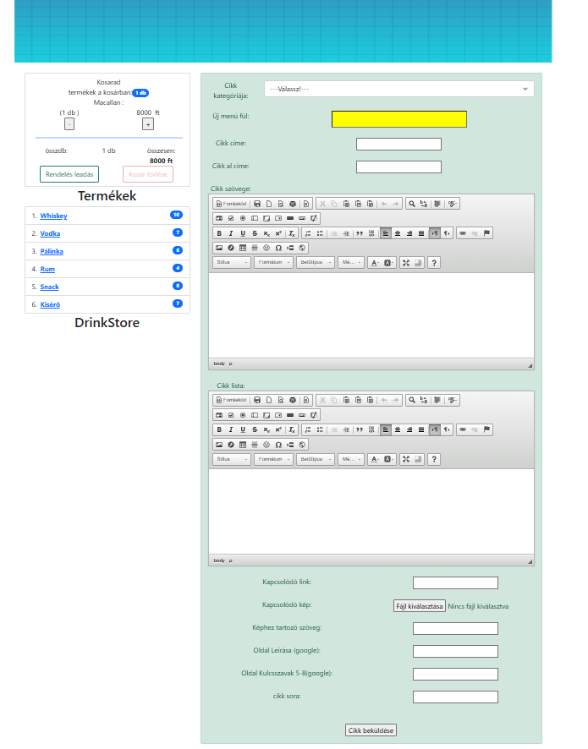
A new menu can be added here together with the article if you enter the new name in the yellow field. Or from the drop-down menu, you have to select the already existing place where the finger article will be placed. Or you are. Either select or create a new one.
The order of the article must be specified, which arranges the already uploaded articles according to listing. This and all other data can be changed later.
The text of the article can be formatted into a plus using ckeditor. Its use is the same as that of a word document. Although those text formatting options are provided this way. We can add more pictures, links, lists, etc.

It is possible to attach a picture in the form, which is recommended to be used for the articles as well! For this, meta data must also be filled in, which is then used by the page for search engine optimization!
The page description and keywords fields are necessary for Google so that the page appears in search results in the Google search engine. For this reason, the text corresponding to the image must be filled in next to the image for uploading!

Admin interface Adding a New Product:
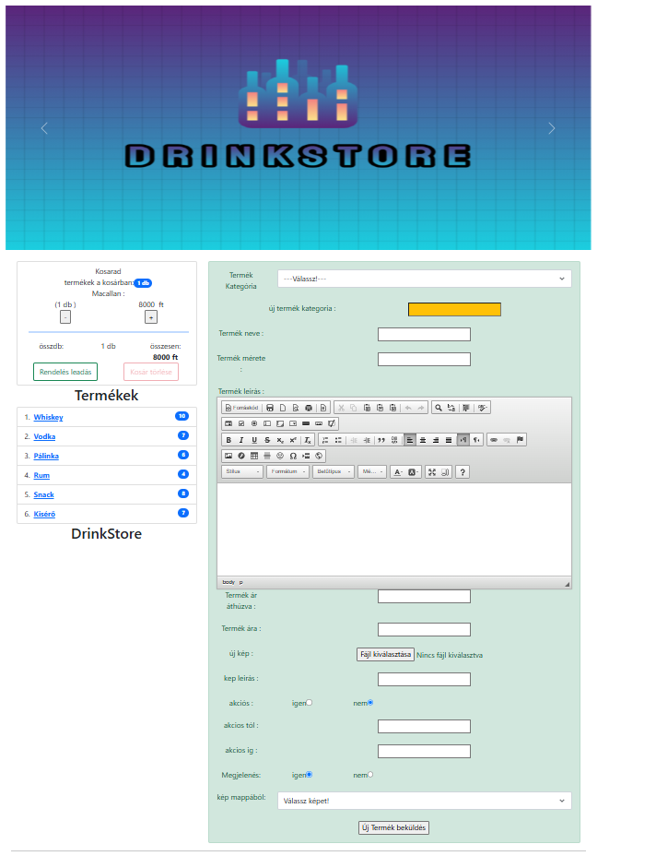
A new product group can also be created here along with uploading the product.
The same applies here as in the case of the new article.

Either select from the drop-down list or add a new product group in the yellow field. here, in addition to uploading images, there is an option to attach images from already uploaded images, this can be found at the bottom of the page under the option to choose an image from a folder! (image display instead of image access and name is part of later development)

Admin interface Article Archive:
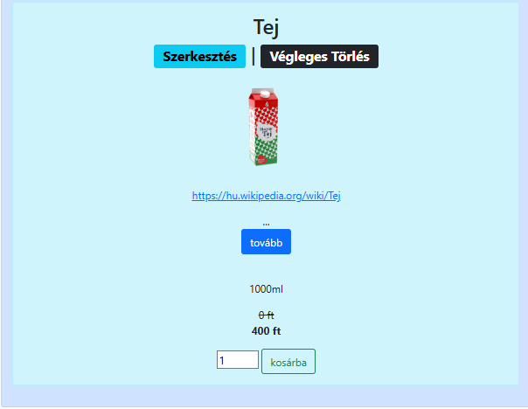
The articles are added to the archive after they have been deleted, and they can be added here even after the menu item has been deleted.
Articles can be removed from the archive by editing or deleting them.
Under each article, you can choose: Editing or Permanent deletion.

Archive Editor:
the article line appears in red, this indicates that the article has been deleted, it does not appear on the page.
If we rewrite this to 1, it can already appear on the page. IF! Has a category. If not, choose from the drop-down menu.
All categories, article titles, sub-titles, article content, page description and keywords can be modified for Google, the attached image and file as well as the description can be changed.
Here it is possible to choose an image from a folder, you can also add an image to the article from among the already uploaded images.

Admin interface Product Archive:
Products are archived after deletion, which is also possible if the product category is deleted.
Products can be removed from the archive by editing or deleting them.

Under each product, you can choose: Edit or Delete permanently
Product editing:
Everything can be modified and rewritten. The category, product name, size, description, price, discount price can be changed. A favorable time can be set. You can add a new image or choose another one from the already uploaded images.
Product deletion:
A pop-up confirmation window asks if you are sure you want to delete the entry?

If we approve this, click OK, then the product will be loaded permanently.

Admin interface Menu sorting:
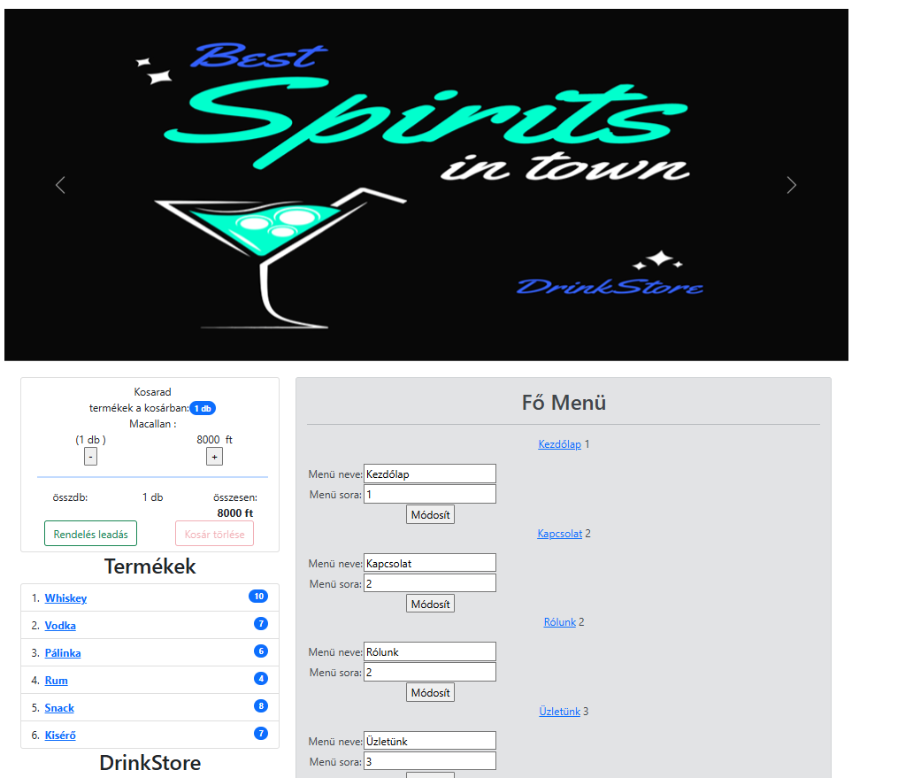Here it is possible to rename the menus and change their order in the lists by changing the row numbers.
Modifications cannot be made as a group, only per menu name.
The link next to the menus takes you to the given menu.
- The main menu is fixed, it cannot be deleted, it can only be sorted and renamed.

- Page menu: when creating an article, the menu items are generated here under the new menu item. They can be renamed, sorted and deleted. By rewriting the line, they are considered deleted to -1, that is, they do not appear in the results on the page.

- Product menu: when creating a product, the categories are generated here under a new product category. They can be renamed, sorted and deleted. By rewriting the line, they are considered deleted to -1, that is, they do not appear in the results on the page.

- By deleting the menu items, the corresponding contents are transferred to the archive, from where they are either deleted, or by giving them a new menu category, the contents become visible again.

Admin interface Rose Diagram:

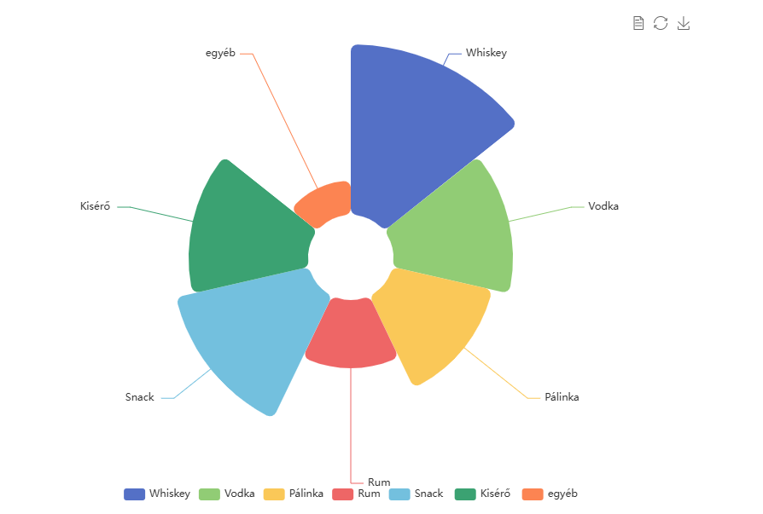
Based on the data in the database, the Rose Diagram shows what we have the most data about in the system.

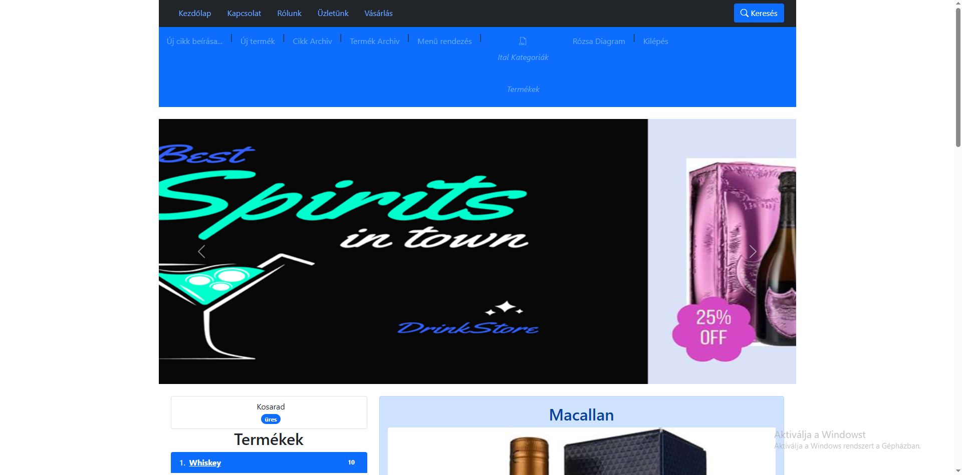
Exiting the Admin interface: you can simply exit the editing section with the button.

Database installation process:
Our database can be installed by importing the attached SQL file. After that, our php file ensuring the connection must be modified if the server is not localhost (my computer) or if a password was set by the administrator when installing the virtual server. In other cases, the data of the running server must be modified in the file.
Installation:
All files in the package must be placed in the appropriate root directory. In the case of Xampp, create a bsproject folder in the htdocs folder, which will contain the 7 folders and the php extension files without more than 10 folders.
So extracting the zip into the htdocs folder is recommended into a folder called bsproject. This is how the program works for us.
On the server, the folder of the domain name provides the folder where the entire content must be uploaded. Currently, the server of tarhelypark.hu runs our site in a live environment, and locally we use xampp.

Summary of Future Developments:
Expected Developments:
Loyalty Program and Discounts:
- Loyalty Program: Offer points for purchases, which can be redeemed for discounts or gifts. This encourages customers to return.
- Coupon Codes and Promotions: Use coupon codes, seasonal promotions, and "Buy more, save more" type discounts.
Inventory and Shipping:
- Stock Monitoring: Mark products with low stock levels and notify customers when the product becomes available again.
- Shipping Options: Provide multiple shipping methods, such as express shipping, free shipping over a certain amount, or the option for in-store pickup.
Customer Reviews and Ratings:
- Reviews and Ratings: Encourage customers to rate the products they’ve purchased and make reviews easily accessible so others can make informed decisions.
Thank you for your attention. We hope that our work so far will be evaluated positively!

